INTERNSHIP TASKS

Name : S. Deva Manikanta

Clg Id : 12119003

Course : Python

Org : IGIAT – VSKP

Date : 12-04-2024

Day 12: EXERCISE – 12

Exercise Level 1

#Task 1:

#Write a function which generates a six digit/character

from random import random, randint;

import string as st;

def random_user_id():

    characters = st.ascii_letters + st.digits*;*

    i = 0*;*

    random_string_user_id = ""

    while (i < 6):

        random_index = randint(0, len(characters)-1)*;*

        random_string_user_id += characters[random_index]*;*

        i += 1*;*

    return random_string_user_id*;*

print("Task 1: Random 6 Digit/Character string --> ", random_user_id())*;*

#Task 2:

#Modify the previous task. Declare a function named user_id_gen_by_user. It doesn't take any parameters but it takes two inputs using input(). One of the inputs is the number of characters and the second input is the number of IDs which are supported to be generated.

def user_id_gen_by_user():

    length_of_each = int(input("Enter the length of each ID : "))*;*

    how_many = int(input("Enter how many IDs do you need : "))*;*

    characters = st.ascii_letters + st.digits*;*

    random_string_user_ids = []*;*

    i = 0*;*

    id = ''

    while (i < how_many):

        j = 0*;*

        while (j < length_of_each):

            random_index = randint(0, len(characters)-1)*;*

            id += characters[random_index]*;*

            j += 1*;*

        random_string_user_ids.append(id)*;*

        id = ''

        i += 1*;*

    for i in random_string_user_ids:

        print(i)*;*

print("Task 2: Random N ids with N length ---> As Follows")*;*

user_id_gen_by_user()*;*

#Task 3:

#Write a function named rgb_color_gen. It will generate rgb colors (3 values ranging from 0 to 255 each).

def rgb_color_gen():

    value_1 = randint(0, 255)*;*

    value_2 = randint(0, 255)*;*

    value_3 = randint(0, 255)*;*

    print(f"rgb({value_1}, {value_2}, {value_3})")*;*

print("Task 3: Random Rgb Color ---> ", end = "")*;*

rgb_color_gen()*;*

**Outputs:**

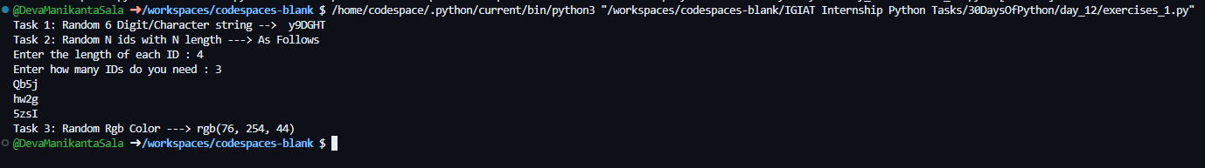

Exercise Level 2

#Task 1:

#Write a function list_of_hexa_colors which returns any number of hexadecimal colors in an array (Six hexadecimal numbers written after #. Hexadecimal numerical system is made out of 16 symbols

#0-9 and first 6 letters of the alphabet -- a-f.)

from random import random, randint;

import string as st;

def list_of_hexa_colors():

    n = int(input("Enter the number of colors do you want? : "))*;*

    characters = st.digits + st.ascii_lowercase[0:6] + st.ascii_uppercase[0:6]*;*

    i = 0*;*

    hexa_colors_list = []

    while(i < n):

        j = 0*;*

        color = "#"

        while (j < 6):

            random_index = randint(0, len(characters)-1)*;*

            color += characters[random_index]*;*

            j += 1*;*

        hexa_colors_list.append(color)*;*

        i += 1*;*

    print("Hexa Colors : ", hexa_colors_list)*;*

print("Task 1: Hexa Colors list.")*;*

list_of_hexa_colors()*;*

#Task 2:

# Write a function list_of_rgb_colors which returns any number of RGB colors in an array

def list_of_rgb_colors():

    n = int(input("Enter the number of colors do you want? : "))*;*

    rgb_colors_list = []

    for i in range(n):

        value_1 = randint(0, 255)*;*

        value_2 = randint(0, 255)*;*

        value_3 = randint(0, 255)*;*

        string = f'rgb({value_1}, {value_2}, {value_3})'*;*

        rgb_colors_list.append(string)*;*

    print("RGB colors : ", rgb_colors_list)*;*

print("Task 2: RGB Colors List")*;*

list_of_rgb_colors()*;*

#Task 3:

# Write a function generate_colors which can generate any number of hexa or rgb colors.

def generate_colors(color_code, n):

    if(color_code.lower() != 'hexa' and color_code.lower() != 'rgb'):

        print(f"Invalid Color Code or {color_code} is not available!")*;*

        return*;*

    elif(color_code.lower() == 'hexa'):

        hexa_colors_list = []*;*

        print("Printing Hexa Colors --", n)*;*

        characters = st.digits + st.ascii_lowercase[0:6] + st.ascii_uppercase[0:6]*;*

        i = 1*;*

        while(i <= n):

            j = 0*;*

            color = '#'*;*

            while(j < 6):

                random_index = randint(0, len(characters)-1)*;*

                color += characters[random_index]*;*

                j += 1*;*

            hexa_colors_list.append(color)*;*

            i += 1*;*

        print(hexa_colors_list)*;*

        return*;*

    else:

        rgb_color_list = []*;*

        i = 1;

        print("Printing RGB Colors --", n)*;*

        while(i <= n):

            value_1 = randint(0, 255)*;*

            value_2 = randint(0, 255)*;*

            value_3 = randint(0, 255)*;*

            string = f'rgb({value_1}, {value_2}, {value_3})'*;*

            rgb_color_list.append(string)*;*

            i += 1*;*

        print(rgb_color_list)*;*

        return*;*

print("Task 3: Color Generator Hexa or RGB")*;*

generate_colors('hexa', 3)*;*

generate_colors('RGB', 4)*;*

generate_colors('HSL', 3)*;*

**Output:**

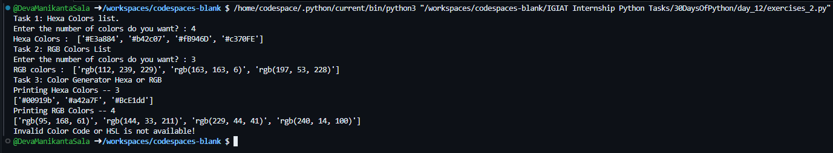

Exercise Level 3

#Task 1:

#Call your function shuffle_list, it takes a list as a parameter and it returns a shuffled list.

import random as r;

def shuffle_list(list_of_items):

    i = 0*;*

    random_index = []*;*

    shuffled_list = []*;*

    while (i < len(list_of_items)):

        random_index_var = r.randint(0, len(list_of_items)-1)*;*

        if random_index_var in random_index:

            continue*;*

            i -= 1*;*

        else:

            shuffled_list.append(list_of_items[random_index_var])*;*

        random_index.append(random_index_var)

        i += 1*;*

    return (shuffled_list)*;*

print("Task 1: The Shuffled List of ['Hi', 'This', 'is', 'Deva Manikanta'] -->",shuffle_list(['Hi', 'This', 'is', 'Deva Manikanta']))

print("Task 1: The Shuffled List of [1, 2, 3, 4, 5, 6, 7, 8, 9, 10] -->",shuffle_list([1, 2, 3, 4, 5, 6, 7, 8, 9, 10]))*;*

print("Task 1: The Shuffled List of [1, 2, 3, 4, 5, 6, 7, 8, 9, 10] -->",shuffle_list([1, 2, 3, 4, 5, 6, 7, 8, 9, 10]))*;*

#Task 2:

#Write a function which returns a array of seven random numbers in a range of 0-9. All the numbers must be unique.

def array_of_seven_random_numbers():

    i = 0*;*

    seven_random_numbers = []*;*

    added = []*;*

    while (i < 7):

        random_number = r.randint(0,9)*;*

        if random_number in added:

            continue*;*

            i -= 1*;*

        else:

            seven_random_numbers.append(random_number)*;*

        added.append(random_number)*;*

        i += 1*;*

    return seven_random_numbers*;*

print("Task 2: The 7 random unique numbers -->", array_of_seven_random_numbers())*;*

**Output:**

